HURTWOOD HOUSE

Education Guardianship Policy and Agreement

Reviewed | By | Last reviewed | Last modified
Annually | SMT | June 2025 | June 2025

Introduction
The school maintains a strong boarding ethos and greatly values the diversity that both its UK and international students bring to our community. Pastoral staff provide vital support to international students, aiding integration and helping them get the most out of their time in the UK. Educational Guardians provide extra support to students, ensuring their welfare in and out of school. An Educational Guardian acts as the overseas parents’ representative in the UK and is independent of School. The types of services a Guardian offers can include but is not limited to arranging homestay accommodation and airport transfers, emergency/crisis support and generally supporting the student during their stay in the UK.
In addition to our responsibilities as outlined in the School’s Child Protection and Safeguarding Policy, the School has particular responsibility under UK Visa and Immigration (UKVI) regulations for international students who hold a Child Student or Student visa. UKVI rules require that care arrangements are ‘suitable’ for students at all times when they are in the UK, and not just when they are in the care of the school.
Additional regulations with which the school must comply regarding the safeguarding and promotion of the welfare of students includes:
- The Children Act 1989
- The National Minimum Standards for Boarding Schools (Sept 2022) which states that the School will take appropriate steps to ensure that the guardianship arrangement is ‘promoting the welfare, physical wellbeing and emotional wellbeing of the boarder’.
During term time the school is responsible for a student’s welfare and acts in loco parentis. However, there are times when the school must be able to hand over these parental responsibilities to an appointed Educational Guardian. For this reason, and in accordance with current UK immigration regulations, the school strongly recommends every student whose parents or legal guardians do not live in the United Kingdom to have an Educational Guardian. In addition, Child Student visas will not be granted by UKVI unless a recognised guardianship arrangement has been confirmed.
The school may request a change of Educational Guardian, or revision of the arrangement, if it is felt necessary. For example (and this should be noted) the school does not consider unsupervised stays in hotels or bed and breakfast accommodation to be an acceptable level of accommodation or care. It is also not considered to be a suitable arrangement for the student to stay in university student accommodation even if this is with a family member.
Educational Guardians are welcome, indeed encouraged, to contact the Housemaster or Housemistress to discuss the student’s academic and social progress, to visit the school to support a student and, if parents authorise them, to have access to student progress data, predicted grades and reports through the school’s MyGrade portal..
Aims of the Guardianship Policy
- To provide the parents of international students (and the guardians they appoint) with a clear explanation of the school’s expectations relating to educational guardianship.
- To ensure the parents of international students understand the responsibilities of the guardian they appoint and that the school must be satisfied that the guardianship arrangement promotes the welfare, physical and emotional wellbeing of the boarder - National Minimum Standards for Boarding Schools 2022.
- To make parents aware that concerns about an educational guardianship arrangement will be acted upon immediately and referred to relevant agencies, as per National Minimum Standard (22.4).
- To ensure parents of international students are aware that the school reserves the right to reject the arrangements planned for their child when they are residing out of school, if deemed unacceptable or inappropriate by the school. The parents will have to make alternative arrangements; the school would be under no obligation to provide a place or continued place at the school if no arrangements deemed acceptable by the school can be put in place. The school will comply with its Child Protection and Safeguarding Policy in this regard which is available to read on our website. The school will also comply with the requirements of its Student Sponsor Licence.
- To provide details on how communications between the school, international parents and guardians will operate.
- To ensure the provision of a Guardianship Agreement which will give the school full details of the appointed guardian and the responsibilities which parents have delegated to them.

Parent Responsibilities

An Educational Guardian is appointed by a student’s parents. The school does not provide specific guidance,but instead refers parents to the following accrediting bodies - AEGIS or BSA if they are having difficulties selecting a suitable person or guardianship company for their child.

The parents must:
- satisfy themselves that the Guardian is a fit person to have unsupervised care of their child
- satisfy themselves that the Guardian can provide suitable accommodation for their child when in the UK but absent from the school
- inform the school if the Guardian is related to the Student and must give details as to how they are related, or confirm that they are using a professional Guardianship Organisation.
- If an appointed Guardian’s details change during a student’s time at the School, it is the parents’ responsibility to ensure accurate updated contact details (telephone, mobile, email and full postal address) are communicated to info@hurtwood.net as soon as possible, in order to ensure continuity of care.
- For those students requiring a visa, the school’s visa consultants will need to be satisfied about the care arrangements prior to issuing a Certificate of Acceptance of Studies (CAS). This evidence will need to be submitted with the details sent to the school’s visa consultants to authorize commencement of the visa application process and will be submitted with the subsequent visa application.
- Parents or guardians must communicate all holiday arrangements in writing with at least one week’s notice to the Housemaster/Housemistress. The school must know the EXACT details of student’s accommodation and the methods of transportation. If there are multiple stays planned for a holiday period, the school must know ALL travel arrangements and host family details in advance.

Who can be an Educational Guardian?

Guardians must:
- Either be a relative, or family friend, who is over 25 years of age and not a full-time student. The age limit is required to ensure emotional maturity and provision of a safe environment. Or; where the family does not have a suitable contact in the UK, be appointed by the parents via a reputable organisation.
- Have UK residency, either as a UK passport holder or with indefinite Leave to Remain (ILR) in the UK.
- Have a high proficiency in the English language.
- Be able to provide a point of contact for the school at all times.
- Be able to reach school within a maximum of 12 hours.
- Be someone with whom the child feels happy and comfortable staying – very much like a family home. Guardian accommodation must be safe, appropriately supervised, and of a good standard. An unacceptable Guardian arrangement would be one in which the environment is not warm and welcoming and/or where numerous young people are staying in one establishment. Unsupervised hotel, B & B, hostel or student accommodation will not be considered acceptable.
- Be expected to uphold the ethos and values of the school at all times.
- Be expected to respect and support the rights, religion, and customs of the student.
- Must not be an employee of the school unless with the express permission of the headmaster.

The School’s Guardianship Agreements are in Appendix 1 and 2 of this policy. A ‘Confirmation of Acceptance of Studies’ (CAS) is necessary for a student if a visa application is required; this document will only be issued by our visa consultants upon receipt of the completed and signed Guardianship Agreement Form, and confirmation by the School that the information supplied is acceptable.

Identity Verification

The school has a duty to undertake appropriate checks on Guardians. Any person undertaking the responsibilities of an Educational Guardian is required to provide the following documents. This is required for the purposes of identity verification and safeguarding:
- A UK passport or an overseas passport which indicates ILR (Indefinite Leave to Remain in the UK)

Where the Guardian is appointed by a guardianship agency, the agency will be required to confirm that:
- it has the evidence specified above, which should be in date for immigration documents
- it has completed all relevant safeguarding checks on the Guardian

Guardian Responsibilities

All Guardians must be prepared to undertake, where necessary, the following responsibilities:
- To be available not only to the student but also to the School as a proxy for the parents. To act with delegated parental authority in the case of an emergency and other matters agreed by the parents.
- To act with delegated parental authority in the case of an emergency or crisis and to make appropriate arrangements and permissions for medical care. If neither parents nor Guardian can be contacted, the Housemaster/Housemistress acts in loco parentis – as if they were the legal Guardian in the best interests of the child.
- To be highly proficient in the English language and contactable at all times by telephone / email and to be in a position to travel to the school at short notice (within 12 hours).
- To provide home-like, safe and suitable accommodation for the student with an appropriate degree of care and supervision when they cannot be accommodated at the School and to liaise with the Housemaster/Housemistress regarding these arrangements. Occasions are likely to include, but are not restricted to:
  - Weekends, half term breaks, and longer holidays
  - Days at the start and end of term when a student’s flights do not coincide with term dates
  - If a student is ill or injured and needs to recuperate away from the School
  - If the School requires a student to leave for disciplinary reasons or because the School determines it to be in the student’s best interests
  - Any other occasion when the student is released from the School
- To undertake parentally delegated responsibilities in an agreement with the parents of the student in order to promote and safeguard the welfare of their child at all times whilst in the UK.
- To promote the physical and emotional wellbeing of the student.
- To be ready to liaise with the Housemaster/Housemistress on behalf of the parents of the above student in any matters relating to the student’s welfare.
- To represent Parents at meetings if requested and authorised to do so by parents.
- If taking charge of travel arrangements, to inform the School about all travel arrangements at the beginning and end of each term, half term and weekend. To communicate all such travel details in writing with at least one week’s notice to the Housemaster/Housemistress. The school must know the EXACT details of student’s accommodation and the methods of transportation. Arrangements for departures and arrivals should be agreed with the Housemaster/Housemistress in accordance with the published term dates.
- To provide up to date telephone, postal address and email address and notify the School in writing of any change of Educational Guardian arrangements.
- To notify the student’s Housemaster/Housemistress if the Guardian is planning to leave the UK and to ensure that the student’s parent(s) have appointed a suitable replacement/temporary guardian to act whilst they are outside the UK.
- To make suitable alternative arrangements if unable to accommodate the student, and to inform both Housemaster/Housemistress and Parents of the arrangements. A Homestay family/Guardian by proxy should also provide all the same identity documents outlined in this policy.

Common occurrences when a guardian would be required in an emergency would include, but are not limited to:
- Emergency hospital appointments (including overnight) and ongoing hospitalisation
- Discipline issues eg housing/caring for the student during times of suspension
- Housing/caring for the student during times of contagious infection
- Collection from airport due to delayed/cancelled flights
- Liaison with immigration authorities in the event of student difficulties on entry or exit to or from the UK

Homestay Arrangements

This is temporary responsibility for the safety and wellbeing of the student, for instance over a weekend or during a school holidays.

This could be:
- Staying with a host family arranged through the appointed Educational Guardian (who will be expected to carry out all required safeguarding checks on the host family).
- Staying with the family of another student of the School where parental permission has been given.

These persons must be in the UK for the entire duration of the student’s stay with them, be over 25 years of age and have the right to reside in the UK. These persons must not be an employee of the school unless with the express permission of the Headmaster.

The Homestay family must take responsibility for the welfare of the student during their stay, remain contactable at all times, make the Housemaster/Housemistress aware of any welfare concerns, and ensure that the student returns to School at the required time.

The Parent/s or the Guardian must provide the student’s Housemaster/Housemistress with details of the person/s with whom the student is staying as part of the Homestay prior to the Homestay.

Student Wellbeing

National Minimum Standards for Boarding Schools (Sept 2022) make clear that “the school [must take] appropriate steps to ensure that the guardianship arrangement is promoting the welfare, physical wellbeing and emotional wellbeing of the boarder.”

The school will monitor arrangements via the following steps:
- The Housemaster/Housemistress will check before a student stays with a Guardian, host family or student-friend’s family that they feel comfortable with the arrangements.
- The School will inform the Guardian, host family or student-friend’s family of any medical or emotional needs of students in their care in advance of their stay.
- Following a stay with a Guardian, host family or student-friend’s family, students will be asked by boarding house staff about the arrangements that were in place.
- In addition, students be encouraged to talk to their Housemaster/mistress to provide feedback on their guardian at regular times during the year.

Any concerns about a Guardianship arrangement will be reported to the Designated Safeguarding Lead and will involve external agencies as and when required.

Authorised by | resolution of the Partners  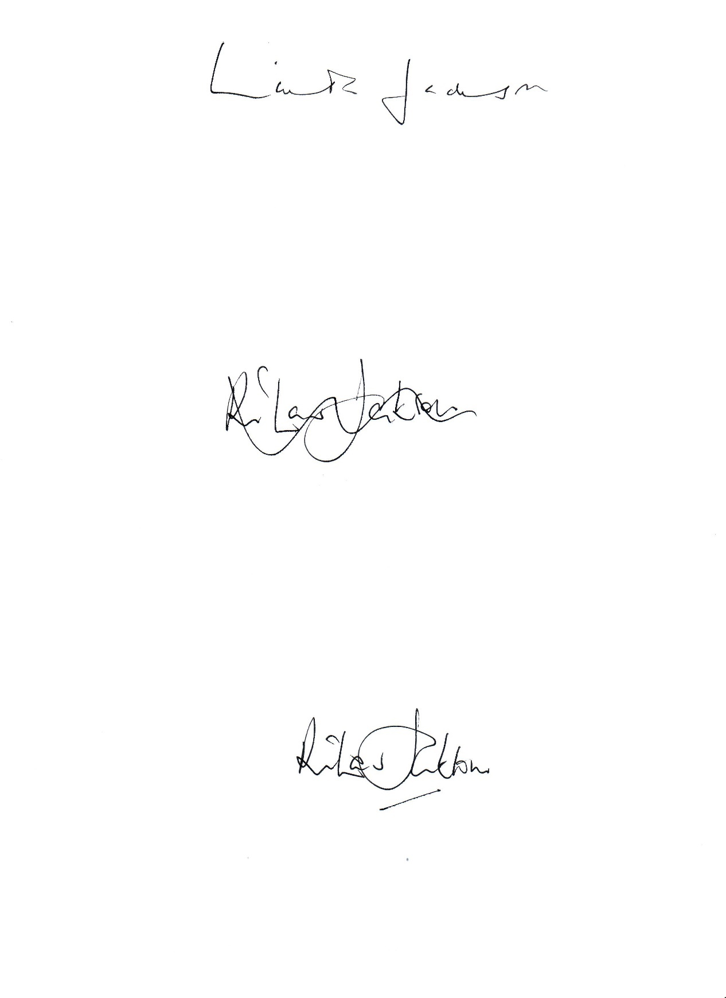  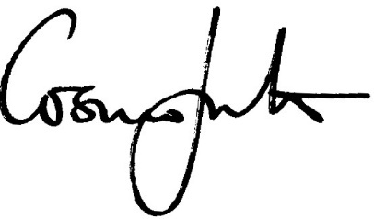
Date | 24/06/2025

Effective date of the policy | 1st September 2025
Circulation | all staff / Parents / Students / Guardians
Status | Complies with:  Education (Independent School Standards) (England) Regulations 2014.  Keeping Children Safe in Education 2025  National Minimum Standards for Boarding 2022

Appendix 1

Education Guardianship Agreement – Nominated Guardian

To whom it may concern,

Student’s Full Name:
Date of Birth:
Nationality: Passport number:

Sponsor: Hurtwood House, Holmbury St Mary, Dorking, Surrey RH5 6NU

I can confirm that I am to be the nominated guardian of STUDENT.

I can confirm that I will be STUDENT’s carer in the UK outside of term-time for less than 28 days and/or is the school’s emergency contact in the UK. I can confirm that I am a British Citizen / settled in the UK and have not been convicted or committed any criminal offence in the UK or overseas.

My contact details are as below:

Full name:
Address:
Phone Number and email address:

The nature of my relationship with the child’s parents (or legal guardian) and myself is DESCRIPTION OF RELATIONSHIP. I can confirm that I agree to all care arrangements in place.

I also confirm that the accommodation and the address I live at is a private residential property and not operated as a commercial enterprise.

Including myself, the occupants at the property are:
Name | Relationship to you

Details of other adults that regularly reside at the property whose primary home is elsewhere:
Name | Permanent UK address | Phone / Email

Other people I support or have offered support as an intended carer are:
Full Name

Yours faithfully,

Signature: ……………………………………………………………………………………………
Name in full: ……………………………………………………………………………………………
Date: ……………………………………………………………………………………………
Address: ……………………………………………………………………………………………
……………………………………………………………………………………………
……………………………………………………………………………………………

Appendix 2

Education Guardianship Agreement – Guardianship Agency

To whom it may concern,

Student’s Full Name:
Date of Birth:
Nationality: Passport number:

Sponsor: Hurtwood House, Holmbury St Mary, Dorking, Surrey RH5 6NU

I can confirm that I have been appointed as the nominated guardian for the above-named student and am not related to them.

I confirm that the student will be living as a full boarding student at the school during term time.

Details of the Guardianship organisation:

Organisation name:
Address:
Phone Number:
Email address:

I can confirm that the date the guardianship organisation was established on:

I can also confirm that all guardians that the organisation uses have a current enhanced Disclosure and Barring Check Certificate.

Yours faithfully,

Signature: ……………………………………………………………………………………………
Name in full: ……………………………………………………………………………………………
Date: ……………………………………………………………………………………………
Address: ……………………………………………………………………………………………
……………………………………………………………………………………………
……………………………………………………………………………………………

